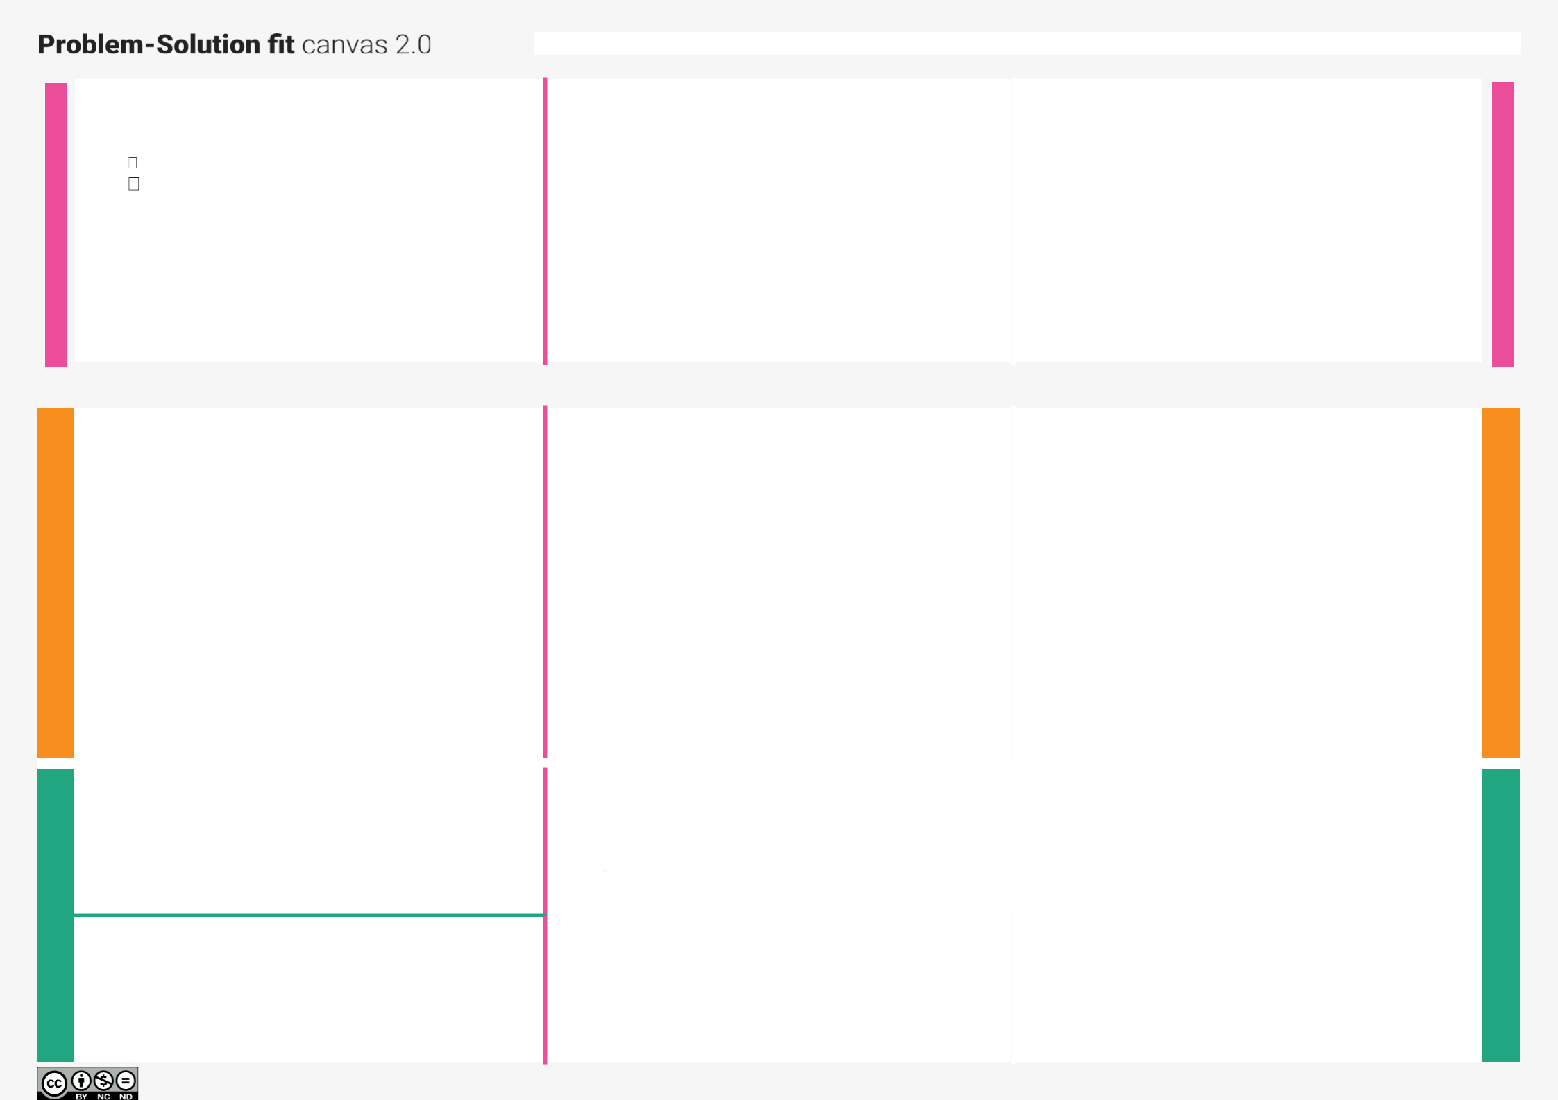
Signs with Smart Connectivity for Better Road Safety

Define CS, fit into CC

1. CUSTOMER SEGMENT(S)

Who is your customer?

highway division

Passenger

CS

6. CUSTOMER CONSTRAINTS CC

What constraints prevent your customers from taking action or limit their choices of solutions?

The impact of the network on the tests was a significant and unexpected element. Given the quantity of sensors, this IoT-based system was successful in simulating a large-scale smart agricultural setting.

5. AVAILABLE SOLUTIONS AS

Which solutions are available to the customers when they face the problem or need to get the job done? What have

they tried in the past? What pros & cons do these solutionshave?

Along roadways, static signs with clear directions areput as potential fixes which gives clear solution.

ExploreAS,

differentiate

Focus on J&P, tap into

Identify strong TR & EM

2. JOBS-TO-BE-DONE / PROBLEMS J&P

Which jobs-to-be-done (or problems) do you address for your customers?

There may be having of different duties, the Smartboard Connectivity is in charge of keeping correct temperature sensor readings and shouldinforming the board of the speed of the customer's vehicle.

3. TRIGGERS TR

What triggers customers to act? i.e. seeing their neighbour installing

Weather will be bad most of the time. The car ought to be travelling at its threshold speed. To alert the customer, the sensor value should be shown on the smart board.

4. EMOTIONS: BEFORE / AFTER

EM

How do customers feel when they face a problem or a job and afterwards?

Clients will feel better after selecting an operation modewith the use of smartboard connectivity, and they will then follow the instructions on the smartboard.

9. PROBLEM ROOT CAUSE RC

What is the real reno sensor readings from the weather would alter the speed restriction. Unnecessary pressing of the accident indicator button by any people could lead to problems.

10. YOUR SOLUTION SL

We employ smart linked sign boards as an alternative to static signboards. With the help of a web app and weather API, these intelligent connected sign boards automatically update with the current speed limits. The speed may rise orfall in response to variations in the weather. The display of

diversion signs is determined by traffic and potentially fatal

situations. As appropriate, there are also signs that read

"Guide (Schools), Warning, and Service" (Hospitals, Restaurants). Using buttons, it is possible to choose from avariety of operating modes.

7. BEHAVIOUR BE

What does your customer do to address the problem and get the job done?

As a teacher, the IOT cloud updates the smartboard on the condition of the roads on a regular basis. So that the customer would address the problem and get the job done.

8. CHANNELS of BEHAVIOUR CH

3.1 ONLINE

What kind of actions do customers take online?

The departments can receive direct emails or messagesfrom customers. (Officers on nearby patrol).

3.2 What kind of actions do customers take offline?

Following directions is one of the major tasks for the traveler, but they can utilize the smartboard signs to checkthe state of the road from wherever they are standing.

Focuson
J&P,tap
int

C

Extractonline
&offline
CHof
BE

